Title [Calibri, 24 points, centered, bold]
Qualification exam proposal

Student Name: [Calibri, 12 points, justified]
Department: Biological Sciences [Calibri, 12 points, justified]
Date of submission: mm/dd/yyyy [Calibri, 12 points, justified]
Table of Contents

Summary 3
1. Section [Calibri, 14 points, bold, justified, 12 points before, 6 points after] 4
1.1. Subsection [Calibri, 12 points, bold, justified, 6 points before, 6 points after] 4
1.1.1. Subsubsection [Calibri, 12 points, bold, justified, 6 points before, 6 points after] 4
References 5

The table of contents should always be on its own page. If you use the predefined styles for sections and sub(sub)sections provided with this template (see below), the table of contents should fill itself up automatically.

Summary
Summary text [Calibri, 12 points, justified].
The proposal must contain a summary of the proposed project not more than one page in length. It must be on its own page and should not contain references. The summary consists of an overview and a statement on the intellectual merit of the proposed activity.
The overview includes a description of the activity that would result if the proposal were funded and a statement of objectives and methods to be employed. The statement on intellectual merit should describe the potential of the proposed activity to advance knowledge.
The Project Summary should be written in the third person, informative to other persons working in the same or related fields, and, insofar as possible, understandable to a scientifically or technically literate lay reader. It should not be an abstract of the proposal.

Section [Calibri, 14 points, bold, justified, 12 points before, 6 points after]

Subsection [Calibri, 12 points, bold, justified, 6 points before, 6 points after]

Subsubsection [Calibri, 12 points, bold, justified, 6 points before, 6 points after]
Maximum page length: 12 pages, not including the title page, table of content, summary and references. Please make sure the pages are all numbered.
The author should use this template to prepare their proposal. Please do not deviate from the predefined styles provided in this document. These styles are:
- Normal [Calibri, 12 points, justified, no starting indentation, 0 point before, 6 points after]: this style should be used for the main text, as well as for the tables and figures legends (but italicized in these cases, see below).
- Heading 1 [Calibri, 14 points, bold, justified, 12 points before, 6 points after]: this style should be used for section titles.
- Heading 2, 3 [[Calibri, 12 points, bold, justified, 6 points before, 6 points after]: this style should be used for subsection and subsubsection titles.
Sections and sub(sub)sections should be numbered as per the following format: 1., 1.1., 1.1.1. The numbering should be automatic if you use the predefined styles included in this document and accessible from the “Styles Panel”.
The project description should provide a clear statement of the work to be undertaken and should include the following recommended sections (which can be themselves organized in subsection at the discretion of the author):
- Introduction. This section should outline the objectives and research questions of the proposed work, its expected significance and intellectual merit, as well as its relation to the longer-term goals of the author. [≈ 1-2 pages]
- State-of-the-art. This section should relate the proposed work to the present state of knowledge in the field, including work in progress by the author (e.g. preliminary data) and previous and current work by other researchers. [≈ 1-2 pages]
- Proposed work. This section should outline the general plan of work, including the broad design of activities to be undertaken, and, where appropriate, provide a clear description of experimental methods and procedures. The author should address what they want to do, why they want to do it, how they plan to do it, how they will know if they succeed, and what benefits could accrue if the project is successful. The project activities may be based on previously established and/or innovative methods and approaches, but in either case must be well justified. This section should include a timeline of the project and a management plan (i.e. how coordination between the different actors of the project will be achieved). [≈ 8-10 pages]
Citations should follow the APA 6th edition formatting (i.e. author, date) as in the following example (Garnier, 2011; Garnier, Caplan, & Kennedy, 2018; Garnier, Gautrais, & Theraulaz, 2007; Garnier et al., 2005). Please use a citation manager (e.g. Zotero, Mendeley, Endnote, etc.) to automatically format and update your references.
Tables [Calibri, 10-12 points] should always be numbered and use the full width of the page. Their legend [Calibri, 12 points, justified, italic] should always be at the top, starting with the table number in bold. If the table contains footnotes, they should be displayed directly below the table. E.g.:
Table 1. Example of a title legend
 | Light | 5 days | 10 days
Control | 12 | 70.3±2.0 | 90±10.5
Test | 12 | 60.4±1.5* | 78±7.9**
Control | 16 | 75.7±8.0 | 100±3.0
Test | 16 | 52.2±1.1 | 81±6.7
*P<0.05; **P<0.01.
Figures should always be numbered and be placed at the center of their own “line”, even when not using the full width of the page (i.e. do not wrap the main text around the figure). This will improve their readability. Their legend [Calibri, 12 points, justified, italic] should always be at the bottom, starting with the figure number in bold. E.g.:
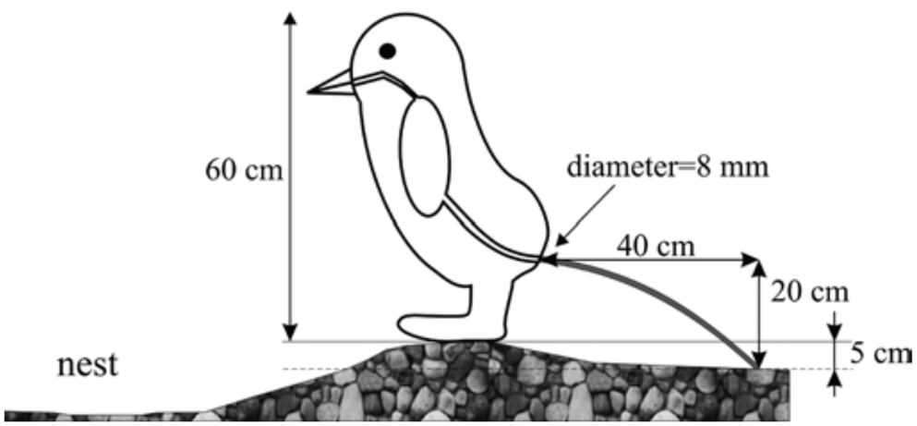
Figure 1. Position of model penguin during defaecation and physical parameters used to calculate rectal pressure necessary to expel faecal material over a distance of 40 cm.

References
References [Calibri, 10 points, justified] should always be displayed on a separate page and follow the APA 6th edition formatting. The first line of a reference should not be indented. If a reference spans multiple lines, each following line should always be indented. No extra spacing is allowed between references.
When available, each reference should include the DOI (Digital Identification Number) of the document. Please check your references for completeness (year, issue number, page numbers, etc.).
Please use a citation manager (e.g. Zotero, Mendeley, Endnote, etc.) to automatically format and update your references.
E.g.:
Garnier, S. (2011). From Ants to Robots and Back: How Robotics Can Contribute to the Study of Collective Animal Behavior. Bio-Inspired Self-Organizing Robotic Systems, 355, 105–120. https://doi.org/10.1007/978-3-642-20760-0_5
Garnier, S., Caplan, J. M., & Kennedy, L. W. (2018). Predicting Dynamical Crime Distribution From Environmental and Social Influences. Frontiers in Applied Mathematics and Statistics, 4, 13. https://doi.org/10.3389/fams.2018.00013
Garnier, S., Gautrais, J., & Theraulaz, G. (2007). The biological principles of swarm intelligence. Swarm Intelligence, 1(1), 3–31. https://doi.org/10.1007/s11721-007-0004-y
Garnier, S., Jost, C., Jeanson, R., Gautrais, J., Asadpour, M., Caprari, G., & Theraulaz, G. (2005). Aggregation Behaviour as a Source of Collective Decision in a Group of Cockroach-Like-Robots. In M. S. Capcarrère, A. A. Freitas, P. J. Bentley, C. G. Johnson, & J. Timmis (Eds.), Advances in Artificial Life (Vol. 3630, pp. 169–178). Berlin, Heidelberg: Springer Berlin Heidelberg. https://doi.org/10.1007/11553090_18
Garnier, S., & Kronauer, D. J. C. (2017). The adaptive significance of phasic colony cycles in army ants. Journal of Theoretical Biology, 428, 43–47. https://doi.org/10.1016/j.jtbi.2017.04.023

